# The Normal Distributions (Page 69-79, Chapter 3)

**TODAY YOU WILL BE ABLE TO…**

* Define and describe density curves
* Describe Normal distributions
* Describe and apply the 68-95-99.7 Rule
* Measure position using percentiles

**RECALL**

* Picturing distributions with graphs   
  (histograms, stem and leaf, and box plots)
* Describing distributions with numbers   
  (mean, standard deviation, 5-number summary)
* Describing the overall pattern – shape, center, and spread – and finding outliers
* Calculating the proportion of outcomes and probabilities

The histogram below shows the time visitors to a museum spent browsing an exhibit on a Saturday. There were 300 visitors that day.

* 1. The shape of the distribution is Skewed Right.
  2. The *number* of visitors that spent less than 25 minutes at the museum that day is closest to 6 + 35 = 41.
  3. The *percent* of visitors spending more than 85 minutes at the museum is closest to (22/300)×100 = 7.3%.



Probabilities are **proportions**. If you choose one of the 300 visitors at random, what is the probability you select one who spent more than 85 minutes at the museum?

P(person spent more than 85 minutes) = 22/300 = 0.0733

**DENSITY CURVES**

Sometimes the overall pattern of a large number of observations is so regular, that we can describe it by a smooth curve.

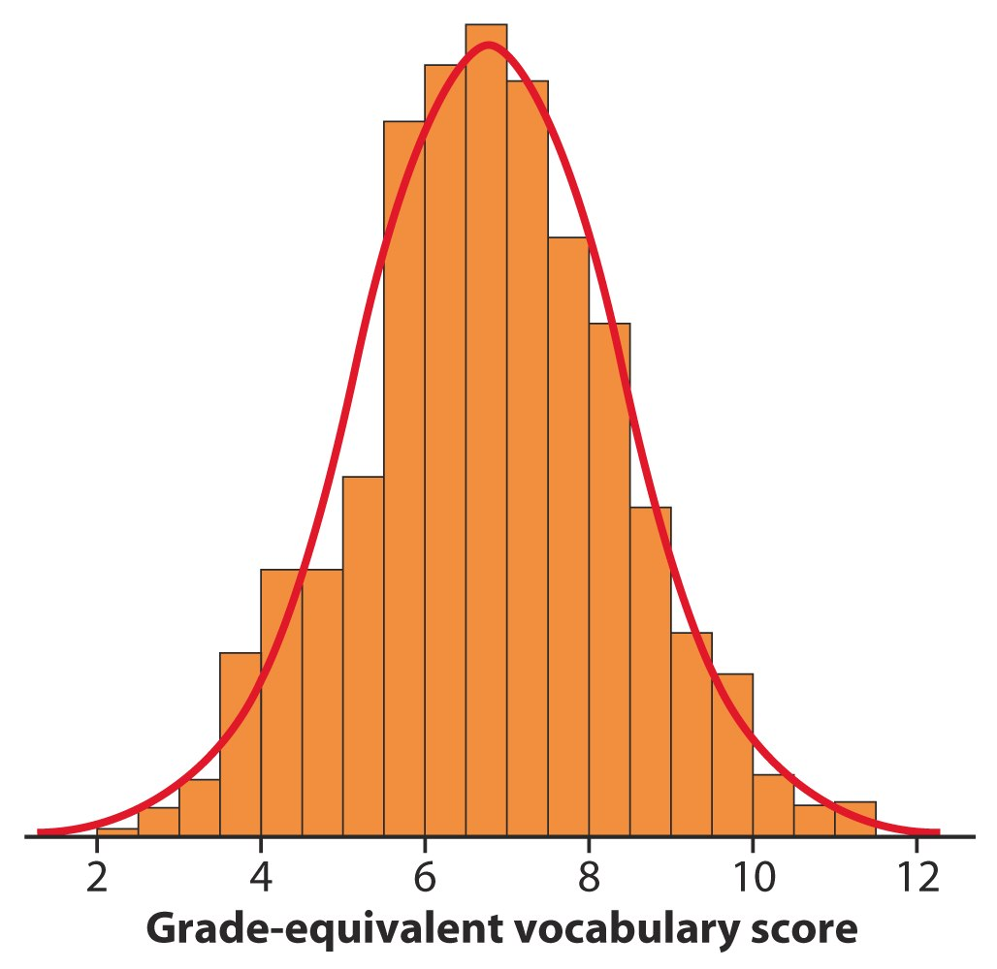

The above histogram illustrates the distribution of Iowa Test vocabulary scores of all (947) seventh-grade students in Gary, Indiana.

* The histogram is symmetric.
* Both tails trail off smoothly from a single center peak.
* The histogram has no large gaps or obvious outliers.

Because the histogram can be described by a smooth density curve, we can easily learn more about the population by simply studying the curve. The area under the density curve and above any range of values is the **proportion** of all observations that fall in that range.

A density curve has the following properties:

* It is always on or above the horizontal axis.
* The total area underneath it is exactly 1.

Density curves come in many shapes like distributions – symmetric, skewed right, skewed left.

A perfectly symmetric distribution has a mean and median that are equal to one another.

A skewed distribution has a long tail that pulls the mean away from the median and toward the tail. *The direction of the tail is the direction of the skew.*

*Skewed right* – A long right tail pulls the mean to the right.

*Skewed left* – A long left tail pulls the mean to the left.

**NOTATION**

$\overline{x}$ represents the *mean* of a set of *sample* values

sx represents the *standard deviation* of the set of *sample* values of x

μ represents the *mean* of a population

σrepresents the *standard deviation* of a population

*N*(*µ,σ*) Normal distribution with mean μ and standard deviation σ

**NORMAL DISTRIBUTIONS**

Normal curves are an important class of density curves with the following properties:

* All Normal curves are symmetric, single-peaked, and bell-shaped
* A specific Normal curve is described by its mean *µ* and standard deviation *σ*.
* The **mean**, μ, of a Normal distribution is the **center** of the symmetric Normal curve**.** The mean controls where the curve is with respect to the horizontal axis.
* The standard deviation is the distance from the center to the change-of-curvature points on either side.
* The **standard deviation**, σ, controls the **spread** of a Normal curve. Curves with larger standard deviations are more spread out. The curve on the left below has a larger standard deviation than the curve on the right.

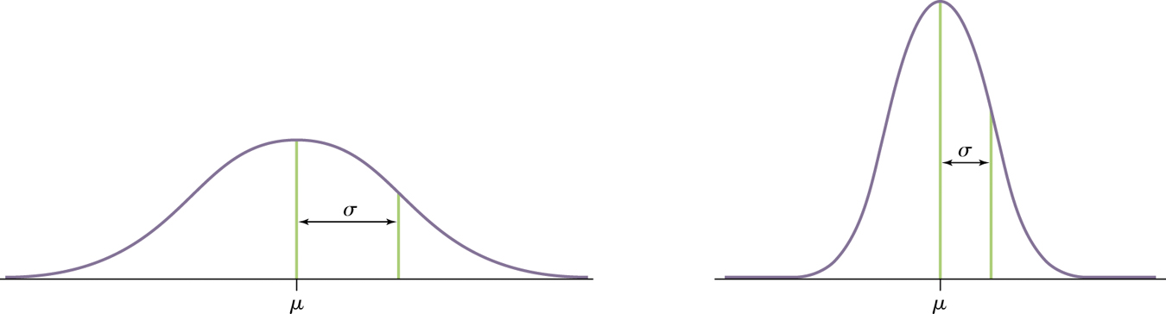

**THE 68-95-99.7 RULE**

In a Normal distribution with mean *µ* and standard deviation *σ*:

* Approximately **68%** of the observations fall within one standard deviation of the mean, i.e., within *σ* of *µ.*
* Approximately **95%** of the observations fall within two standard deviations of the mean, i.e., within 2*σ* of *µ.*
* Approximately **99.7%** of the observations fall within three standard deviations of the mean, i.e., within 3*σ* of *µ.*

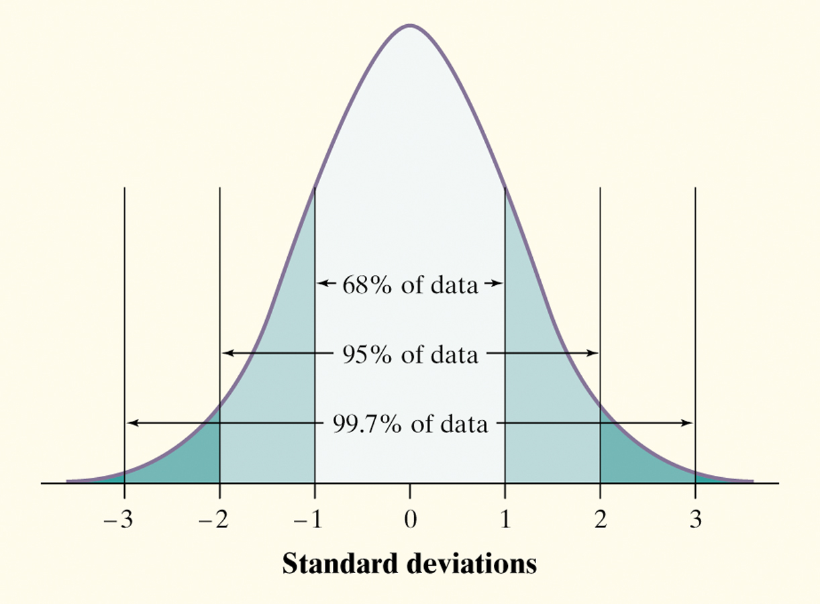

***Example 1:*** The distribution of Iowa Test of Basic Skills (ITBS) vocabulary scores for 7th-grade students in Gary, Indiana, is close to Normal. Suppose the distribution is N(6.84, 1.55).

1. Sketch the Normal density curve for this distribution.
2. What percent of ITBS vocabulary scores are less than 3.74?
3. What percent of the scores are between 5.29 and 9.94?

# The Normal Distributions (Page 80-88, Chapter 3)

**TODAY YOU WILL BE ABLE TO…**

* Describe the standard Normal distribution
* Measure position using z-scores
* Perform Normal calculations

The 68-95-99.7 rule is just one property that is shared by all Normal distributions. If we know that a distribution is normal and if we know the mean, μ, and the standard deviation, *σ*, we can find proportions and actual values.

Normal distributions are all the same if we measure the distance a value is from the mean, μ, in terms of standard deviations, *σ.* Changing to units of size *σ* is called *standardizing*.

If x is an observation from a distribution that has mean, μ, and standard deviation, *σ*, the standardized value of x is

$$z= \frac{x- μ}{σ}$$

The standard Normal distribution has mean 0 and standard deviation 1, i.e., N(0,1). All standardized values have the standard Normal distribution.

***Example 2:*** Compare ACT and SAT scores

The ACT and SAT are measured in different units. To compare scores from each test, the values must be standardized to convert the units to the number of standard deviations from the mean.

The distribution of 2010 ACT Math scores was Normal with mean 21 and standard deviation 5.3, i.e., N(21, 5.3).

The distribution of 2010 SAT Math scores was Normal with mean 516 and standard deviation 116, i.e., N(516, 116).

John scored **26** on the Math portion of the ACT.

Alysha scored **670** on the Math portion of the SAT.

Assuming both tests measure the same kind of ability, who had the higher score?

**THE STANDARD NORMAL TABLE**

Because all Normal distributions are the same when we standardize, we can find areas under any Normal curve from a single table.

***Table A*** is a table of areas under the standard Normal curve. The table entry for each value ***z*** is the area under the curve to the left of *z*.

**Solving Problems Involving Normal Distributions**

**State:** Express the problem in terms of the observed variable *x*.

**Plan:** Draw a picture of the distribution and shade the area of interest under the curve.

**Do:** Perform calculations.

* ***Standardize*** *x* to restate the problem in terms of a standard Normal variable *z*.
* ***Use Table A*** and the fact that the total area under the curve is 1 to find the required area under the standard Normal curve or to find the required data value.

**Conclude:** Write your conclusion in the context of the problem.